Module Assembly - TopCoder NodeJS Auth0 Callback API v1.0 Deployment Guide

Revision History
Author | Revision Number | Date
TCASSEMBLER | 1.0 | 2014/04/07

Deployment Instructions 3
1. Organization of Submission 3
2. Application Setup 3
2.1. Preconditions 3
2.2. Build Script Setup 3
2.3. Auth0 Setup 4
3. Database setup 9
4. Configurations 9
5. Deployment Instructions 10
6. Verification by tests 11
7. Verification by pages 11
8. Resource Contact List 17

Deployment Instructions

Organization of Submission
The folder structure (the root directory of the submission is referred as the <base> throughout the document)
Name | Description
tc-api/ | Main application source code of this assembly.  Contains only new or changed files.
test_file/ | The test file.
tc-api/docs/Module Assembly - TopCoder NodeJS Auth0 Callback API v1.0.doc | This file.

Application Setup

Preconditions
- Linux 64bit System (preferably the Ubuntu 10.04), which is used by Heroku stack for Nodejs), with development tool, such as g++, maker.
- NodeJS 0.10.21 http://nodejs.org/
- Git
- Heroku Account and Toolbelt
  - Signup a Heroku account in https://api.heroku.com/signup/devcenter with your email address.
  - Download the Heroku Toolbelt from https://toolbelt.heroku.com, and make sure the Heroku CLI is working in your environment by typing the “heroku help”.
  - Login your Heroku account by typing the “heroku login”.
This requires you to input your email and password, and then finally it will upload your public SSH key to the server so that you don’t have to provide your credential during the subsequent commands.
If you have a “Permission denied (publickey)” error during deployment, you can use “heroku keys:add” to add the public key to the remote repo as described here.

Build Script Setup
Two BASH scripts are used to ease the deployment.
- deploy/development.sh
It helps to launch the application locally.
It simply exports the configured environment variables and then launch the Node.js application.
- deploy/heroku.sh
It helps to deploy the application onto the Heroku cloud.
It has command line switches.
Switch | Description
clean | It cleans the current repository information by simply removing the .git folder.
commit | It initializes the local repository and commits all the current project files, if the current directory is not a GIT repo yet; or commit all the changes to the local repository, if the current directory is already a GIT repo.
create | It creates a Heroku app for the current logged-in Heroku account.  This app will only be used if it is created when the current local GIT repo has not yet setup the remote repo of name “heroku”.  If your local repo has already setup “heroku” remote for an existing app, this app will not be picked as the target app for other Heroku commands. If you want to create an new Heroku app and use it as the target app in this case, you can clean and re-initialize the current local repo first, or you explicitly rebase it to the new Heroku app.
config | It exports all the configured environment variables to the target Heroku app.
push | It pushes the current committed version to the “heroku” remote.
launch | It launches one Heroku dyno to run the target app.
all | It will execute all other steps in the order: “clean”, “commit”, “create”, “config”, “push”, and then “launch”.
deploy | It only executes the steps to deploy the projects to the Heroku cloud: “config”, “push”, and then “launch”.  It assumes the code has been committed to the local repo, and the local repo has setup the “heroku” remote for the target app.

Auth0 Setup
- Normal auth0 setting
Open www.auth0.com , create a new account if you don’t have one.
Click Login button, input user name / password and login.
Click Applications menu, click new button.
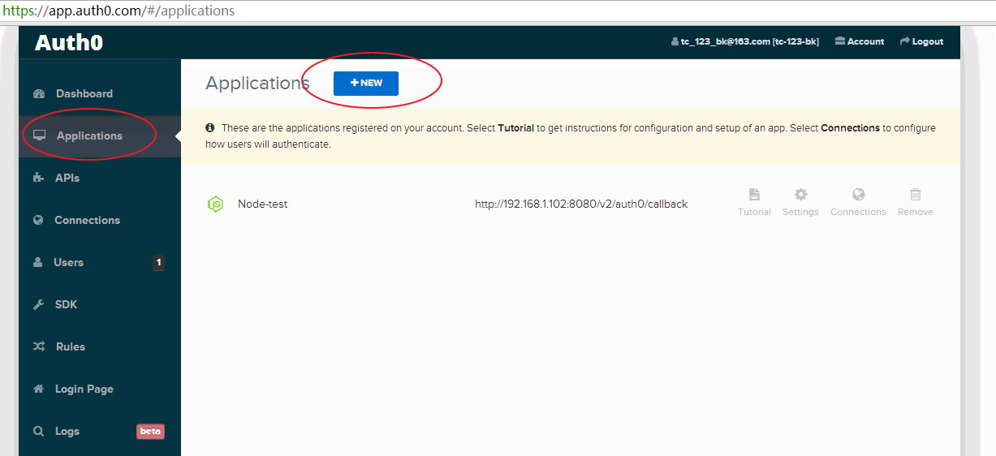
Select Node. Input “Node-test” as name. Click continue button.
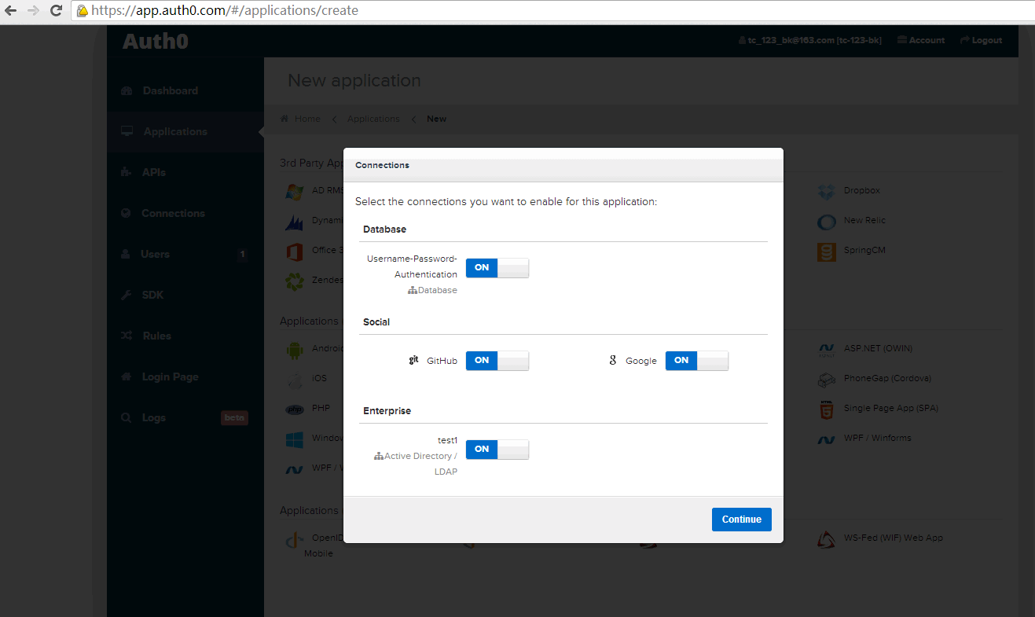
Click Applications menu, click setting link on the “Node-test” row.
Input <<your domain>>/v2/auth0/callback (for example, http://192.168.1.102:8080/v2/auth0/callback in my test) to App Callbacks URLs fields. Save it.
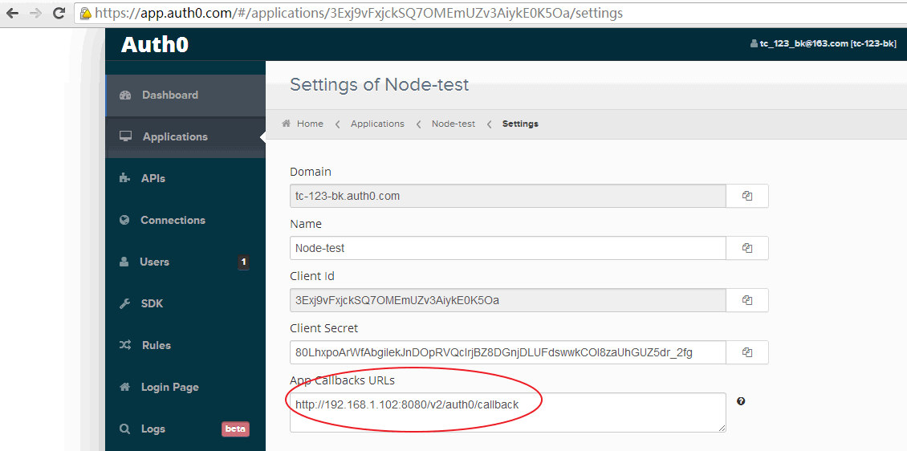

Click Connections -> Social menu, enable google and github. Disable all others.
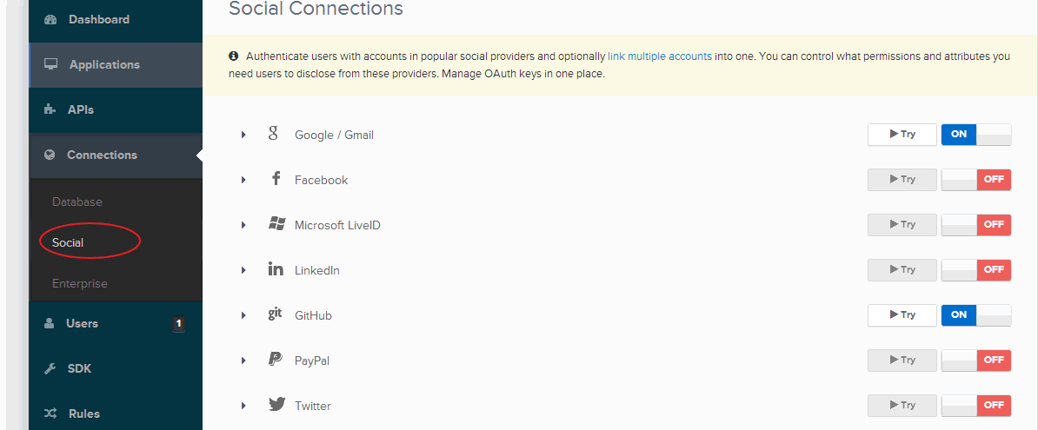

- LDAP connector setting
Download auth0.zip from http://apps.topcoder.com/forums/?module=Thread&threadID=814935&start=0.
Follow auth0/doc/PoC Assembly - Auth0 and LDAP Integration Deployment Guide-v1.1.doc to setup LDAP connector in Cent OS 64 bit. It’s unnecessary to modify the TC VM. Just make sure Cent OS can access the TC VM LDAP.
After setup, test it in Auth0. Click Connections -> Enterprise -> Try it. Input heffan / password. It should get success result.
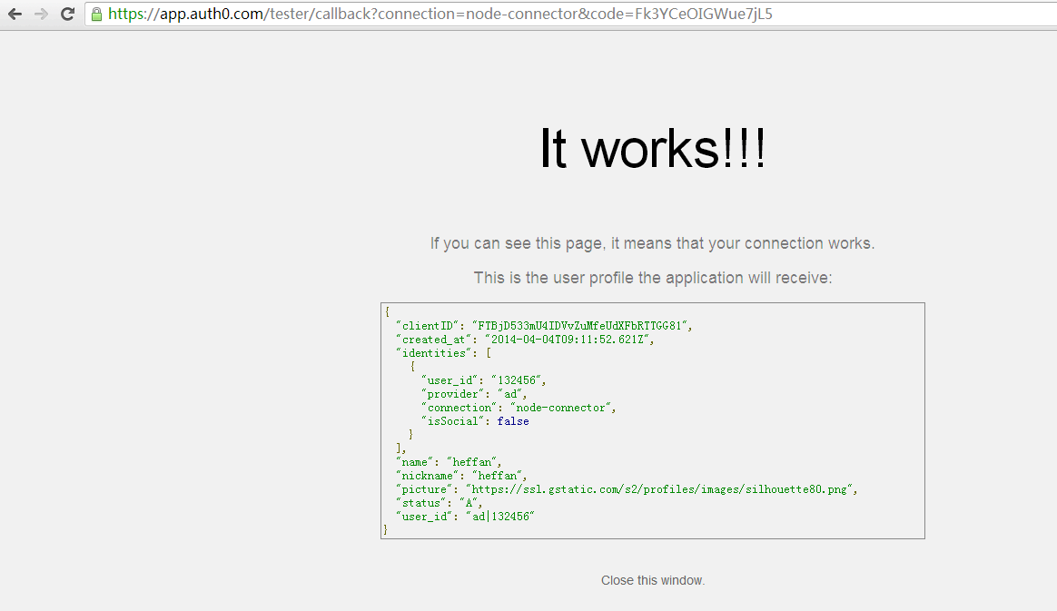
In Cent OS output, you can see the connector output.
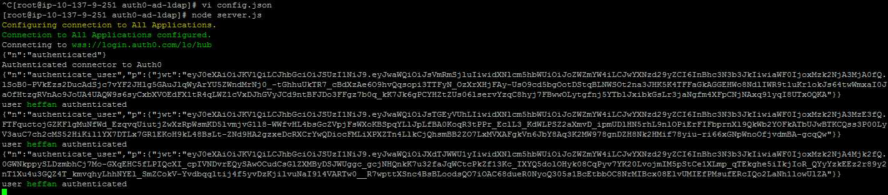
In Applications -> Connections, make sure the LDAP is enable.
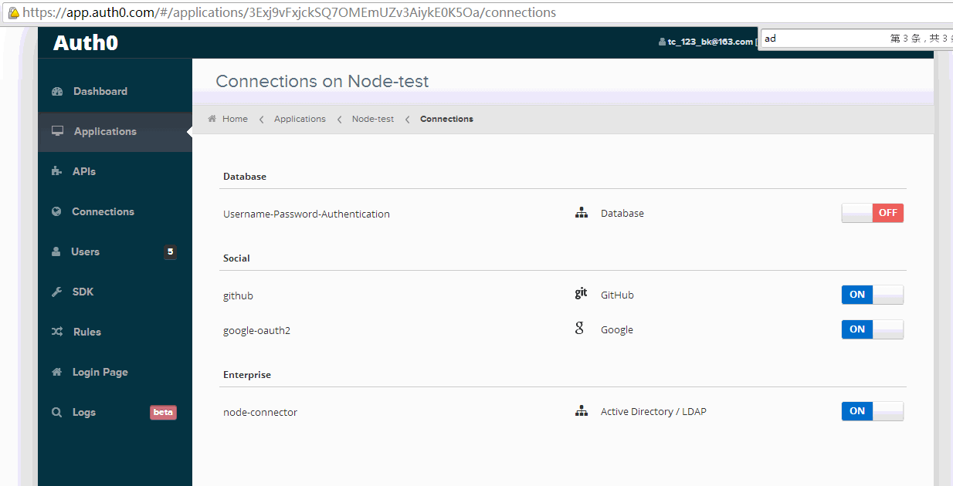

In Applications -> Setting, set Allowed Origins. You need to add your domain name of server which contains test.html, in my test, it is http://localhost:8080/ .
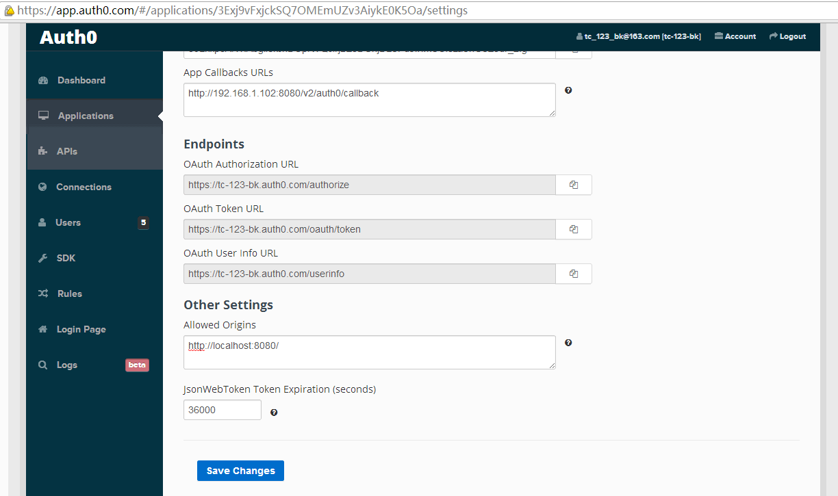

Database setup
There is no database setup required for this contest.

Configurations
There are two BASH scripts used to ease the deployments and launching of the application.
The configurations are defined in these scripts to export the environment variables.
One of them is for local development “tc-api/deploy/development.sh”, where you need to set VM_IP with your actual VM IP.
VM_IP=54.204.93.129

No changes are required to tc-api/deploy/heroku.sh.

In this contest, a new config.auth0 object is added to the config.js. Its fields are described below:
Configuration | Description
oauthDomain | The domain used for connecting to auth0 server.  This value is superseded by an environment variable of the name OAUTH_DOMAIN, if it exists.
oauthClientId | The client ID used for connecting to auth0 server.  This value is superseded by an environment variable of the name OAUTH_CLIENT_ID, if it exists.
clientSecret | The client secret used for connecting to auth0 server.  This value is superseded by an environment variable of the name AUTH0_CLIENT_SECRET, if it exists.
serverName | The server name used for connecting to auth0 server.  This value is superseded by an environment variable of the name AUTH0_SERVER_NAME, if it exists.
redirectUrl | The redirect url used for connecting to auth0 server.  This value is superseded by an environment variable of the name AUTH0_REDIRECT_URL, if it exists.

NOTE: For testing, you must set all above values in config.js and test_file/test.html.
- About auth0 related values,
Login www.auth0.com , click Applications menu, click setting of application, you can see the domain / client id / client secret.
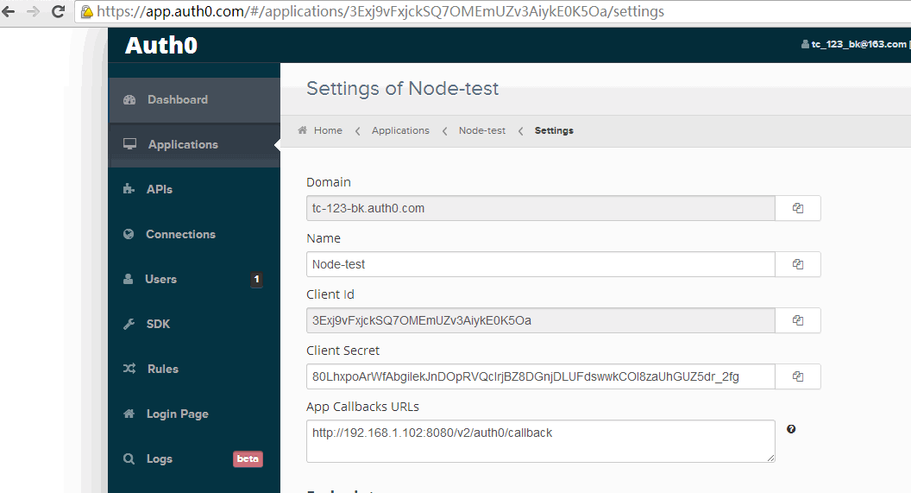

- About server name and redirect url,
The server name should be in the same callback url domain.

Deployment Instructions
- Setup heroku as described in section 2
- Setup Auth0 as described in section 2.3
- Setup database as described in section 3.
- Run git clone https://github.com/cloudspokes/tc-api
The commit to use is e52997d81b1896aa47943dbb1b73d669da447450
- Copy all files from submission/tc-api to checked out tc-api and override all files
- Replace VM_IP and setup the configuration as described in section 4.
- Run npm install
- To deploy application in heroku environment run:
  - chmod +x deploy/heroku.sh
  - . deploy/heroku.sh all
  - Update server name and redirect url in config.js / test.html / auth0 setting as described in section 4.
  - Redeploy to heroku.
. deploy/heroku.sh commit
. deploy/heroku.sh push
  - After running the script, you can use “git remote -v” to see the “heroku” remote repo. The remote repo will be like git@heroku.com:<app-name>.git, you can know the create app name here.
- To deploy application in local environment run:
  - chmod +x deploy/development.sh
  - . deploy/development.sh
  - npm start
  - Server is listening on port 8080.

Notes, make sure all *.sh files are in Unix format if you’re using Ubuntu.

Verification by tests
  - Js lint
Install the node-jslint in your local environment globally by “sudo npm install jslint -g".
Check the following files under the <base>/tc-api
jslint -nomen actions/auth0.js
jslint -nomen test/test.auth0ViewUrl.js
jslint -nomen config.js
jslint -nomen routes.js

  - Mocha
Make sure the server is running, if not use npm start.
Now, run “node_modules/.bin/mocha test/test.auth0ViewUrl.js” from within the “<base>/tc-api/” directory.
There are 2 tests which should all pass.
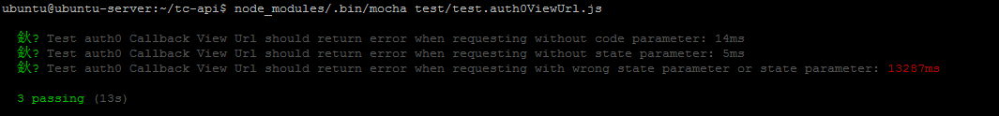

Verification by pages
Please check apiary.apib for the updated docs.

Copy test_file directory to a web container. I’m using apache-tomcat-6.0.39 but it should also work in other web container. In my test, I copied the test.html and js directory into ROOT directory.
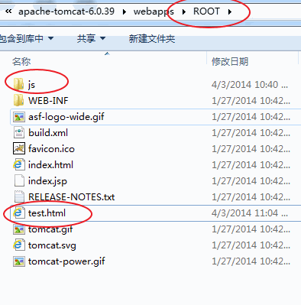
Start web container. Open the test page in browser. In my test, it’s http://localhost:8080/test.html
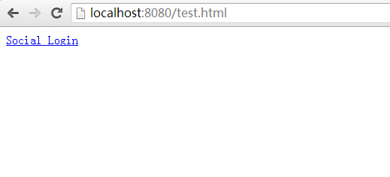

7.1 Test with github login

7.1.1 Update database.
In your VM database, run following sql under common_oltp database. Replace the social_user_name and social_email with your github username and email. You can get them from https://github.com/settings/emails after you login.
insert into user_social_login(social_user_id, user_id, social_login_provider_id, social_user_name, social_email, social_email_verified) values (11111, 132456, 4, 'tc123bk', 'tc123bk@163.com', 'f');

7.1.2 Test in page
Open http://localhost:8080/test.html , click social login, select github, input username / password. Wait a moment and you can see the output.
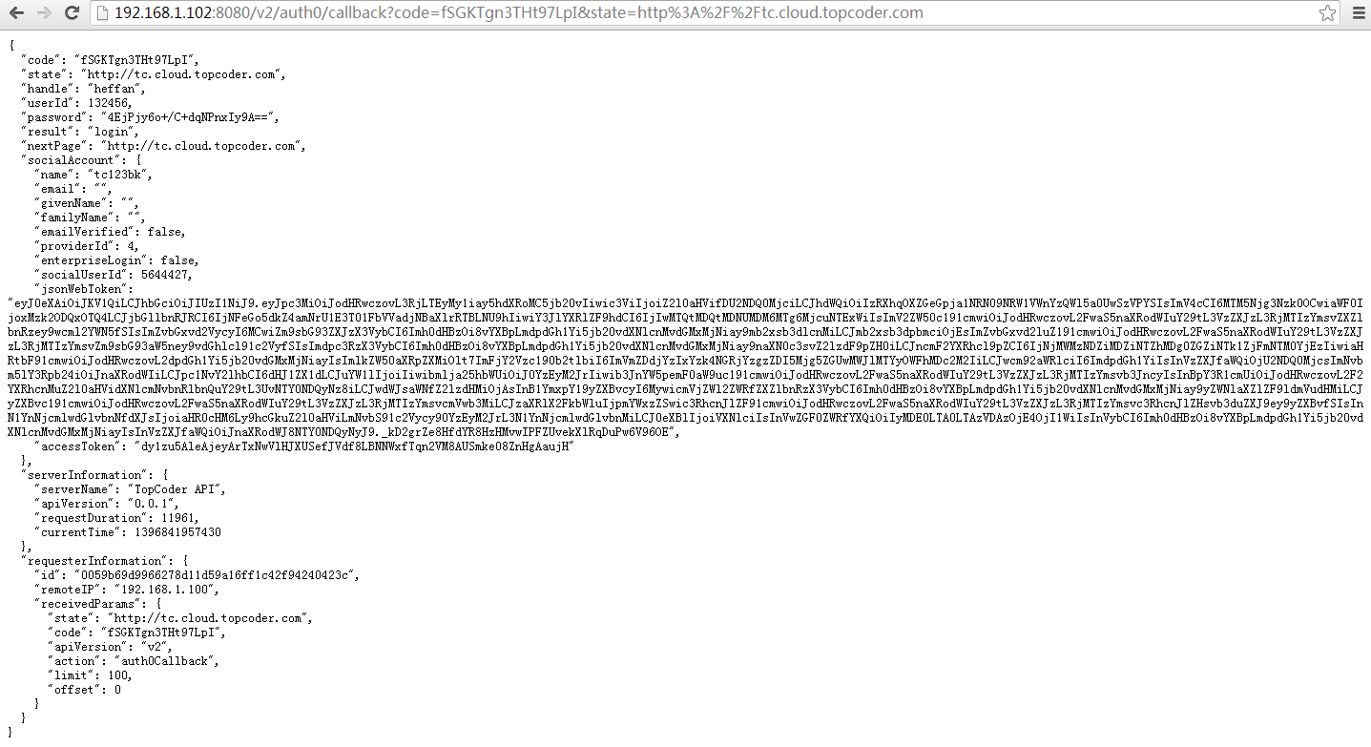

Run following sql under common_oltp database.
select * from user_social_login;
You can see the social_user_id field is updated.
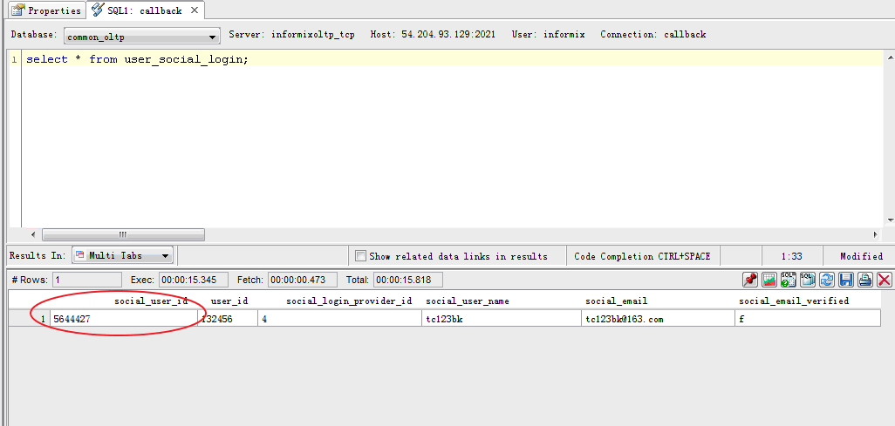

Here is the output log in local server.
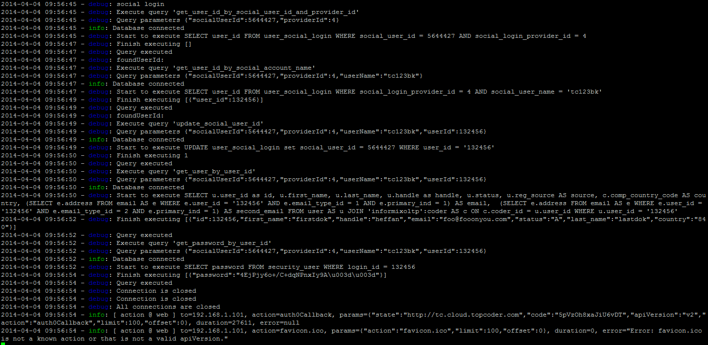

7.2 Test with google login

Open http://localhost:8080/test.html , click social login, select google, input username / password. Wait a moment and you can see the output. It’ll redirect to register url because there is no record in user_social_login table.
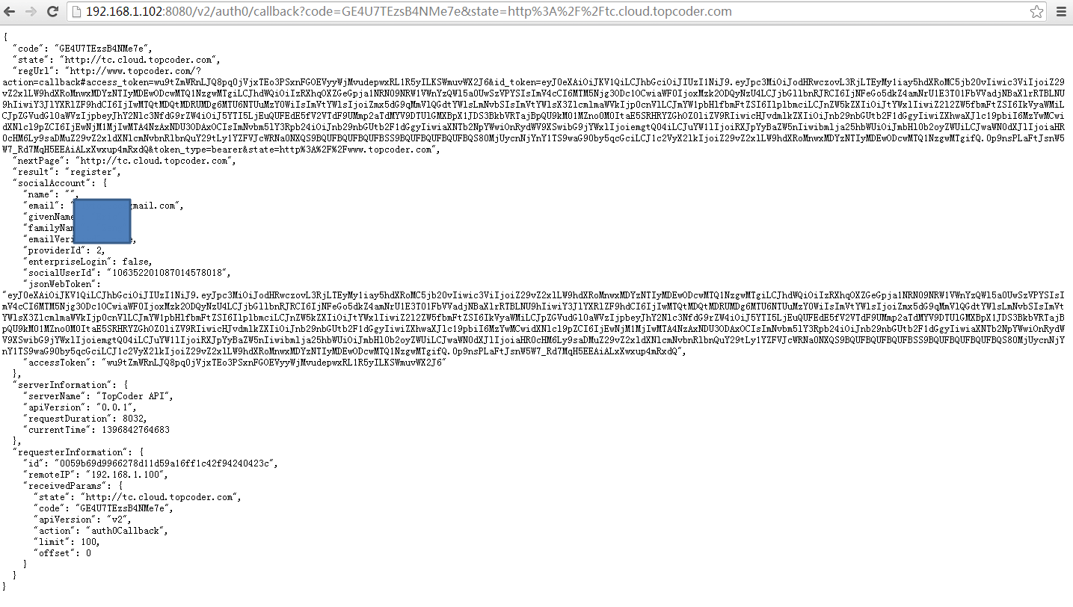

Here is the output log in backend.
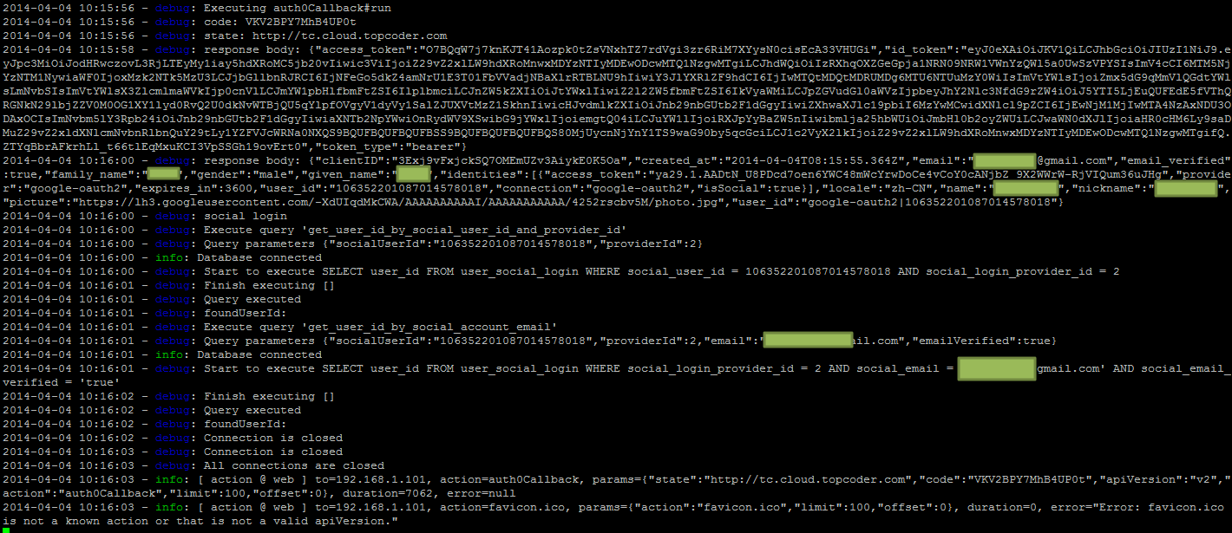

7.3 Test with LDAP login
Open http://localhost:8080/test.html , click social login, input heffan / password, click login button. Wait a moment and you can see the output. It’ll get the user info from database.
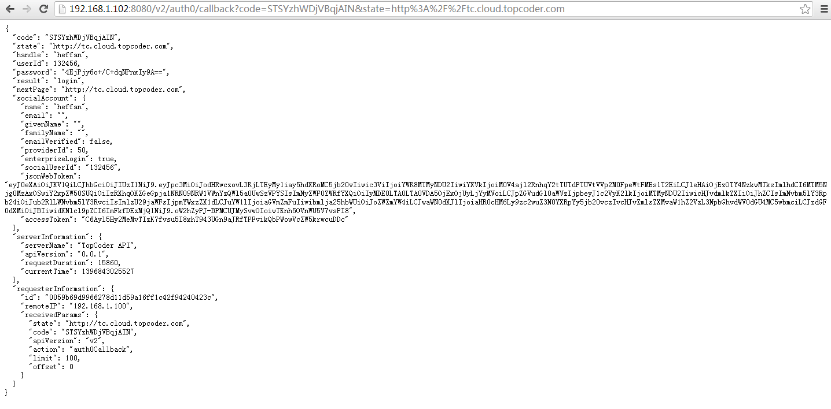

Here is the output log in backend.
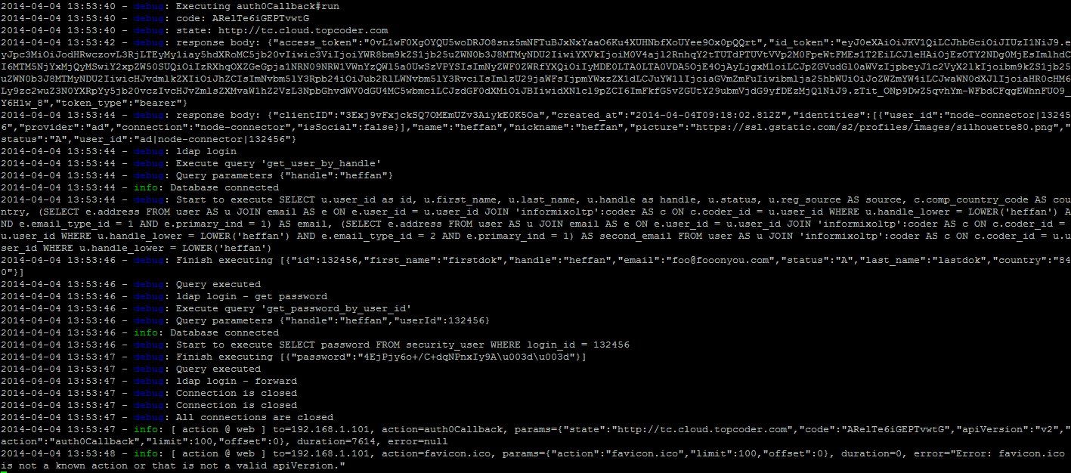

7.4 Test in heroku
I deployed this assembly to http://fathomless-chamber-8234.herokuapp.com/ .
In test.html, use following setting:
domain: 'tc-123-bk.auth0.com',
clientID: '3Exj9vFxjckSQ7OMEmUZv3AiykE0K5Oa',
callbackURL: 'http://fathomless-chamber-8234.herokuapp.com/v2/auth0/callback'

It also needs to update auth0 setting and config.js.

Login with LDAP.
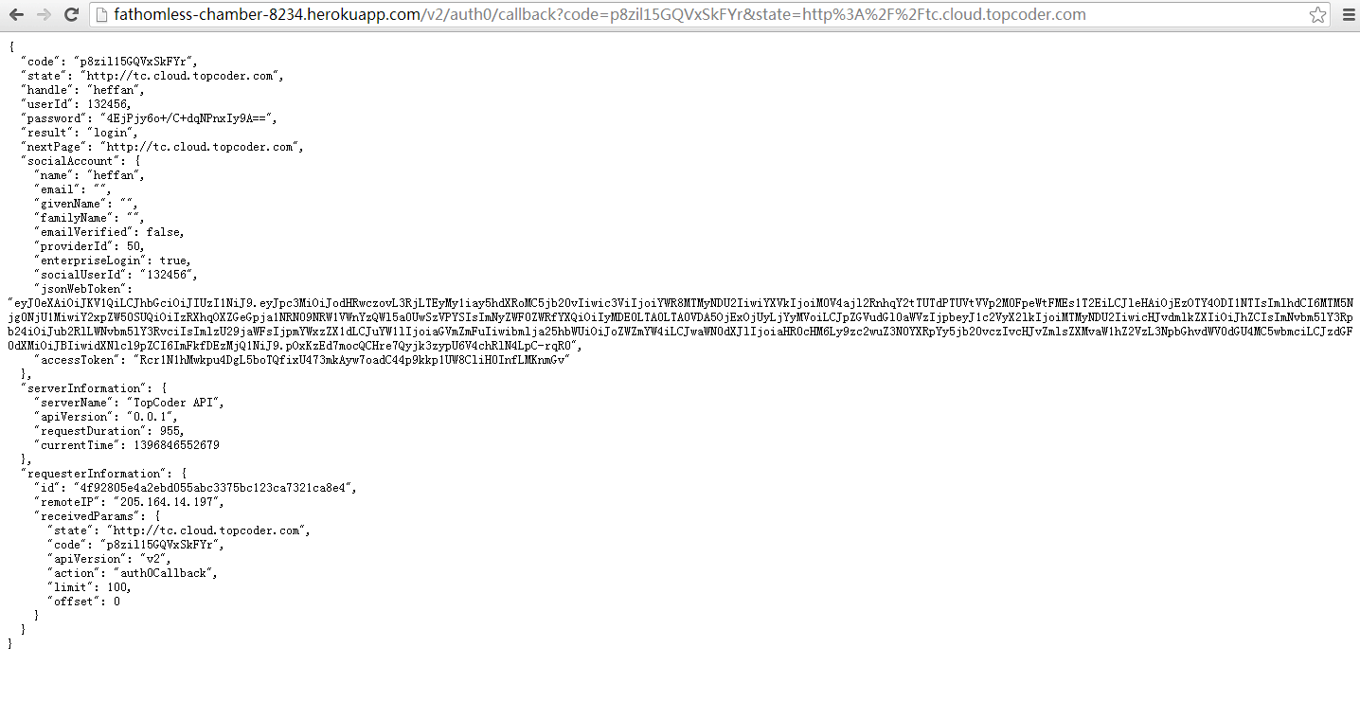

Login with github.
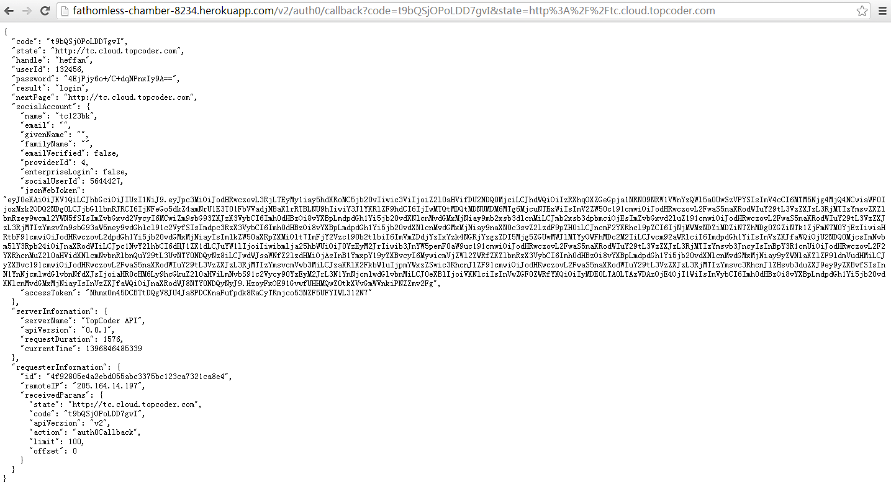

Login with gmail.
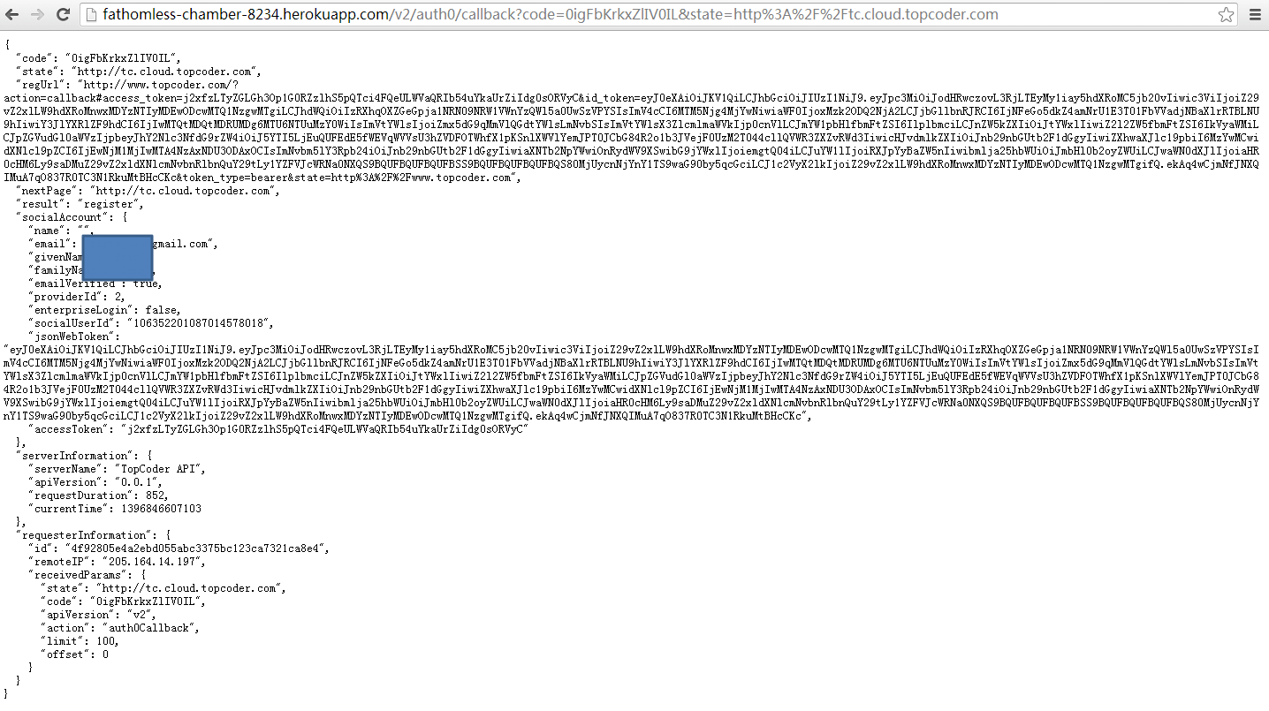

Resource Contact List
Name | Resource Email
TCSASSEMBLER

